

|  |
| --- |
| Misys FusionInvest |
| Trade Mapping Toolkit |
| As prepared for Mediolanum |

|  |
| --- |
| Mac Aodha, Sean  [Date] |



Contents

Document Control 2

Purpose 2

Version 2

Business Requirement 3

Common Identifier 3

Configured Structures 3

Portfolio 3

Nostro Account 4

Third Parties 5

Implementation Requirement 5

Toolkit Parameters 5

Mapping 6

Portfolio 6

Third Parties 6

Nostro Settlement Path 6

**© Misys Limited   
All rights reserved**

**Registered in   
England & Wales**

No. 01360027

**Registered Office:**One Kingdom Street Paddington   
London W2 6BL  
United Kingdom

Document Control

Purpose

The purpose of this document is to outline the Toolkit requirement for the Mediolanum implementation in respect to Trade Upload and mapping a external common identifier to configured Portfolios, Third Parties and Nostro Accounts

Version

|  |  |  |  |
| --- | --- | --- | --- |
| Version | Date | Author | Comment |
| 1.0 | July 2016 | Seán Mac AODHA | Initial Version |
| 2.0 | July 2016 | Yuanjia Su | Add technical details |

Business Requirement

The bulk of trading done for Funds at Mediolanum is executed by Delegate Managers on Mediolanum’s behalf. These trades must be uploaded to the Platform. The trades are supplied by the Fund Administrator, RBC in CSV format. A Common Identifier is used to identify which Fund and Delegate Manager the trade belongs to.

An Integration Service Connector (Rich Market Adaptor, FileConnector or STP Exporter) will convert the CSV to standard fpml (using a Stylesheet where required) and supply input to Integration Service Data Exchange for upload to the Portfolio structure.

The purpose of this toolkit is to map this Common identifier to a Fund sub-portfolio, Delegate Manager and Nostro Account.

The Delegate Manager is referenced on the Trade as the Broker party.

Common Identifier

The agreed common identifier is a concatenation of the RBC Fund Identifier and the RBC Delegate Manager Identifier

**Example**

DB4223**Z**9173803

DB4223:- Challenge International Equity Fund

9173803:- The Delegate Manager

This will be supplied in the input file for each trade.

Configured Structures

Portfolio

The portfolio structure is based on the following grouping

Mediolanum Legal Entity / Fund Group / Fund / Delegate Manager / Strategy

**Example**

MIFL / CHALLENGE / Challenge European Equity / BlackRock / Equity

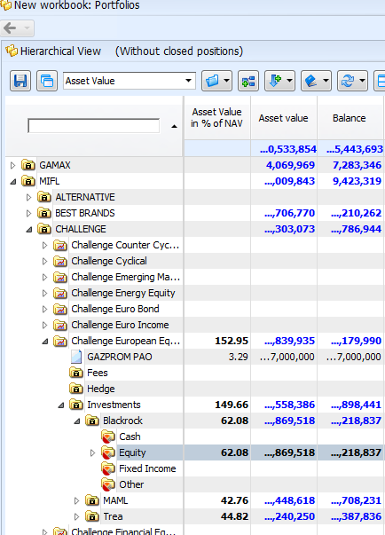

The agreed folio structure in terms of Delegate sub-folios is as above but the Toolkit should be flexible to allow booking of trades in other folios under the delegate manager’s root.

Nostro Account

Each Delegate per Fund has a single Nostro Account. The Common identifier is used as the Account at Custodian value. As usual, the Beneficiary of the Account is the Fund Entity.

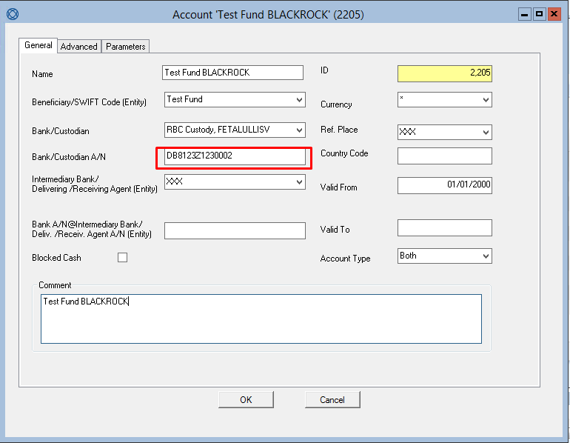

The External References on the Nostro account can be used as a single point to map the additional required objects like Portfolio and Third Party, effectively breaking down and mapping the Common Identifier to the Portfolio Root and Delegate Manager (Broker) on the Trade.

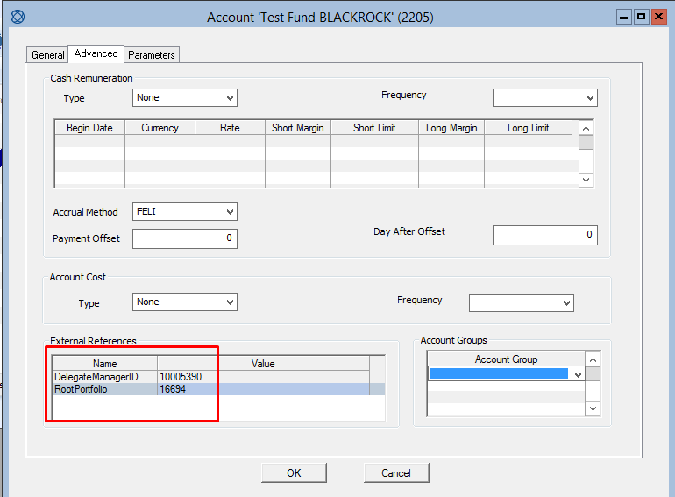

Third Parties

The parties involved in delegate trades are as follows

|  |  |  |
| --- | --- | --- |
| Field | Value | Source |
| Entity | Fund Entity | Entity on Nostro Account. Otherwise automatically determined by folio setup per standard |
| Counterparty | DELEGATE | Supplied by the configured Integration Service Connector suppling the input file |
| Broker | Delegate Manager | Identified by Toolkit using External Reference on Nostro Account |
| Depository | RBC Custody | Supplied by the configured Integration Service Connector suppling the input file |

Where the broker is identified using the Toolkit, the Reference to be used in the External References field on the Nostro Account should be the Sophis ID number of the Delegate Manager.

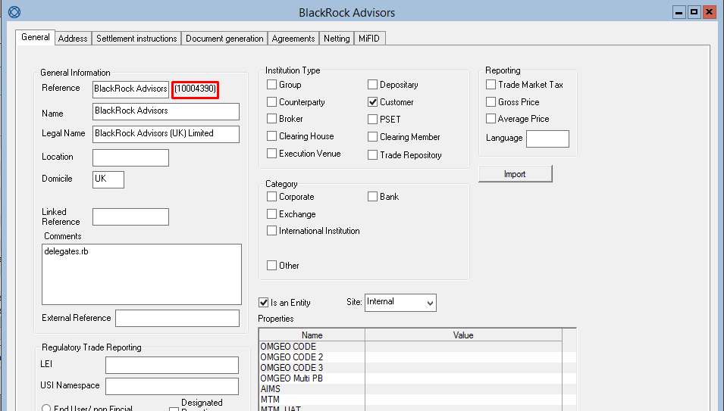

Implementation Requirement

The toolkit should intercept the XML input to the Data Exchange Service and take parameters from the extra fields block within the Trade xml.

Toolkit Parameters

The extra fields supplied as parameters to the toolkit should be as follows:

|  |  |
| --- | --- |
| Extra Field | Example Input |
| CommonIdentifier | DB8123Z1230002 |
| TargetStrategy | Fixed Income |

Proposed technical solutions

**Part 1: Parse the extra fields in CSV**

**Option1**: Rich Market Adapter (RMA)

RMA is in charge of the process to transfer receiving message (support various formats, such as fixing, csv, TS Link etc.) to fpml for IS.

The toolkit will enable RMA to pick up the extra fields after the standards ones are parsed, and IS will match them into the user columns in the transaction tables.

**Option 2**: SophisETL

ETL is simply an acronym for this Extract – Transform – Load approach.

Misys has developed its own implementation of the ETL pattern using the Steps (or Blocks) approach. A Step is responsible for a basic operation applied on a Data Record. There are three kinds of step:

Extract steps produce data records from a specific input stream (such as a CSV file, a relational Database, or a Web Service reply)

Transform steps acts directly on the flow of data records, changing them in the process (examples are a conversion to XML, grouping of records together, merging, filtering, mathematical operations on record fields, etc.)

Load steps consumes the data records and pushes them into a specific output stream

ETL Interface main purpose is to true up Sophis with data sent from external source. Depends on the interface, data can be read from csv file or QS_SS_SLH103 table in database. It will serve the similar purpose as RMA, however the set-up and configuration will be more complex.

ETL_Chains

Chain_I7A_UnitPrices

Chain_I7B_UnitQuantities

Extract_I1

Extract_I2

Extract_I3

\

Transform 1

Transform 2

Doc

Logs

Reports

SophisETL

common.ini

CommonEnv.bat

Scripts, configuration and templates for I3

Scripts, configuration and templates for …

Scripts, configuration and templates for I1

Scripts, configuration and templates for I2

Scripts, configuration and templates for I7A

Scripts, configuration and templates for …

Documentation and Sample Import Files

Scripts, configuration and templates for I7B

Log files for all interfaces

Reports for all interfaces

Binaries (exe and dll files) for all Interfaces

Configuration for all Interfaces

Common script to be called by all Interfaces

Folder

File

SQL

Pre-requisite SQL Scripts

Load

Scripts, configuration and templates for …

Scripts, configuration and templates for …

Comparing the two options, we are more inclined to the first option considering per requirement’s complexity, although we would have a full control of the data flow on the second option.

**Part 2: Map/update trade folio id, broker, nostro settlement path**

Upon trade creation, a toolkit trade action will load the prepared fields, and update the above properties.

Field “TargetStrategy” will allow the flexibility to reallocate trades to different folios under the delegated manager account by matching the strategy name; however the portfolio structure should be the same across all delegated funds.

Mapping

Portfolio

The Portfolio is identified using the following sql using TargetStrategy and CommonIdentifier as parameters

SELECT ident FROM folio WHERE name = 'Fixed Income' AND mgr = (SELECT value FROM bo_treasury_ext_ref WHERE ref_id = (SELECT ref_id FROM bo_treasury_ext_ref_def WHERE ref_name = 'RootPortfolio') AND acc_id = (SELECT id FROM bo_treasury_account WHERE account_at_custodian = 'DB8123Z1230002'));

Third Parties

The Delegate Manager (Broker on Trade) is identified using the following sql, taking CommonIdentifier as a parameter

SELECT value FROM bo_treasury_ext_ref WHERE ref_id = (SELECT ref_id FROM bo_treasury_ext_ref_def WHERE ref_name = 'DelegateManagerID') and acc_id = (SELECT id FROM bo_treasury_account WHERE account_at_custodian = 'DB8123Z1230002');

Nostro Settlement Path

It is required to over-ride the Nostro Account selection determined by the SSI selector so the trade is reported against the Delegate Manager’s nostro account rather than Mediolanum Asset Management’s.

It should be sufficient to over-ride the SSI selector using Nostro Account Id which is determined by

SELECT id FROM bo_treasury_account WHERE account_at_custodian = 'DB8123Z1230002';

